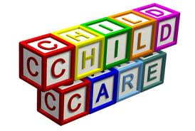

Child Care Center
Disaster Response Handbook

This document was adapted from and in collaboration with:


Disaster Preparedness and Response
Sarpy / Cass Department of Health
701 Olson Drive, Suite 101
Papillion, NE 68046
402-339-4334

Snohomish Health District
3020 Rucker Avenue, Ste. 300
Everett, WA 98201
425.339.5278

Explanation of Handbook:

The Sarpy/Cass Department of Health located in Papillion, NE has received permission to edit this document which is a model disaster plan originally created jointly by Snohomish County Department of Emergency Management, Snohomish Health District Communicable Disease Outreach Program and Everett Office of Emergency Management in Washington.

Not all facilities and communities are alike. This plan is a template that must be individualized for each child care center, taking into account the available resources, the surrounding community, and each facility’s characteristics.

This document contains many sections marked in red that need to be filled in by you with specific information relevant to your center. Make sure to take out any red words in parentheses or in italics that were put in to help you complete this document. Do not hesitate to add additional points to reflect your center’s needs. You are encouraged to contact your local emergency management office to determine what hazards may affect your center location and whether your site is included in a specific hazard area like a floodplain or tornado hazard area.

Make sure you read through the entire plan as you work on it. If any items are unclear or are in conflict with what you believe you would do in an emergency situation, be sure to make changes. For example, if your center is not in a flood zone, take out the section on flooding.

Once finalized, your disaster response plan should be able to be used as a guide for any disaster – by any adult – on the premises. Use your disaster plan to conduct routine drills, to train your staff, and to inform parents about your plans.

Note: The table of contents has been set up so that it can be easily updated. Make all changes to the document, including any page breaks. When you are finished, click once somewhere in the middle of the table of contents which should select the entire table. Then right click, select “update field” and then “update entire table.” The table of contents will automatically update itself.

_________________________________’s
(Child Care Center’s Name)
Disaster Response Handbook

The purpose of this handbook is to give child care center personnel step-by-step procedures on how to respond to disaster/crisis situations during the first 30 minutes. Following the listed instructions in sequential order will help to prioritize notification of emergency response personnel and to limit escalation and injury during the initial impact of the situation. In this document, “Director” means the center director or the person-in-charge at the time of the incident or disaster. “Parent” means the child’s parent or legal guardian.

This handbook was created by Snohomish Health District Communicable Disease Outreach Program and the Washington State Department of Early Learning. Sarpy/Cass Department of Health has received permission to edit it to address Eastern Nebraska hazards. Each child care center has a responsibility to individualize the plan to suit their particular circumstances.

This policy was last reviewed and updated on: ___________________________

OUR CENTER’S ADDRESS IS: ________________________
________________________
________________________

OUR CENTER’S PHONE NUMBER IS: ___________________

OUR NEAREST CROSS-STREETS ARE: __________________
__________________
OUR OUT – OF – AREA CONTACT IS: __________________
Phone Number: __________________

Table of Contents

Emergency Phone Numbers 5
Introduction 5
Preparing for a disaster 6
Gather information from parents 8
Practicing for a disaster 8
Take care of staff 8
Steps to Take During a Disaster 9
Building and Site Evacuation 9
Building Evacuation: 9
Site Evacuation: 10
Shelter-in-Place Procedure 11
Fire Alarm/Emergency 12
Gas Leak 13
External Hazardous Materials Accident 14
Internal Hazardous Materials Accident 14
Power Outage 15
Storms & Snow 15
Earthquake 16
Flooding 17
Missing Child 18
Kidnapping 18
Child Abuse 19
Assault on Child or Staff 19
Intruder Alert Procedure / Lockdown / Building Lockout 20
Intruder Alert / Lockdown 20
Building Lockout 22
Suspicious Mail or Package 22
Communicable Disease Outbreak 23
Field Trip Incident 24
Bomb Threat 25
Coordinating a Response 26
Incident Command System 26
ICS Organizational Charts 29
Crisis Support 38
Crisis Communications 39
Parent-Child Reunification 40
Reunification Stations 41
Release Procedure 42
Appendices 44
Appendix A: Sample Parent Letter 45
Appendix B: Disaster Supplies 47
Appendix C: Hazard Mitigation 55
Appendix D: Disaster Drill Records 57
Appendix E: Sample Situation Forms 65
Appendix F: Child Care Situation Report Form 66
Appendix G: Helping Children Cope with Disaster 68

Emergency Phone Numbers

Emergency Assistance Number(s)
Police 911
Fire/Emergency Medical Personnel 911
_____________Hospital Emergency Room (list your local # here)
_____________Hospital Emergency Room (list your local # here)
Poison Control Center 800-222-1222
National Response Center
(Report Oil & Toxic Chemical Spills) 800-424-8802
Utility Emergency Numbers:
Electricity (NPPD- Power Outages/Lines Down) 877-275-6773
Electricity (OPPD- Power Outages/Lines Down) 888-554-6773
Gas (Black Hills Energy – Emergency) 800-694-8989
Metropolitan Utilities District (MUD) –
Emergency Line 402-554-7777
Telephone (Outages & Repairs) 611
Water & Sewer: (list your local # here)
Radio/Television Stations:
Channel 3 – KMTV 402-592-3333
Channel 6 – WOWT 402-346-6666
Channel 7 – KETV 402- 978-8954
Channel 42 – KPTM 402-552-4282
Channel 10/11 - KOLN-TV 402-467-4321
Channel 8 - KLKN-TV 402-434-8000
Child Protective Services 800-652-1999
Child Care Licensing 402-471-9562
Specialist: ______________________ (list your local # here)
Sarpy Cass Department of Health & Wellness
Emergency Preparedness Staff 402-339-4334

Alternate Site Location (Near Child Care Center):
_(List the address here)___________________ (list the telephone number here)

Alternate Site Location (Evacuation Site) :
_(List the address here)___________________ (list the telephone number here)

Introduction

In order to ensure the safety of all the children who attend this center and the staff who work here, this center has developed a comprehensive Crisis/Disaster Response handbook. By putting together this plan and sharing it with parents, we are working to be prepared when disaster strikes.

Preparing for a disaster
This child care center has taken many steps to prepare the facility, children, staff, and parents, for the unexpected. Child care centers must follow NE Statute FCCH1; 391NAC1; 1-006.23D for disaster planning and NE Statute FCCH1; 391NAC1; 1-006.23B for fire drills.

Conducting Drills
Drills are essential to provide staff with the skills necessary to respond in times of an emergency. There are 3 different emergency drills that should be practiced on a regular basis. Sample forms for recording drills are found in Appendix E.
- Fire (evacuation drill) – must be practiced monthly, as required by NE Statute FCCH1; 391NAC1; 1-006.23B Tornado drill – rapid movement to safe room/shelter should be practiced quarterly, minimum.
- Earthquake (Drop, Cover, & Hold) – should be practiced yearly, minimum
- Lockdown (secure building, stay together) – should be practiced quarterly, minimum
- The center conducts fire drills on a monthly basis and records the dates as required by licensing.
- The center conducts disaster drills on a quarterly/monthly basis and records the dates.
- There are two designated escape routes from each area. Evacuation maps are posted in each classroom.
- Other

Kits
Having adequate supplies is essential to 72-hour preparedness. See Appendix B for more information about recommended supplies.
- The center has gathered a 72-hour preparedness kit and has included a 72-hour supply of any medications or supplies for those with special needs. This kit / These kits are kept (where).
- The center checks its emergency kits and emergency medication expiration dates on a regular basis. This is done (how often).
- For those with special needs or life-threatening health conditions who require medication or supplies on a regular basis or on an as-needed basis, those medications or supplies are kept on-site and will be taken along if evacuation is required.
- Fire extinguishers are located throughout the center. The locations are (where). They are checked monthly and recharged (how often).
- The center’s smoke alarms are checked monthly.
- (If source of carbon monoxide is present) The center has a carbon monoxide alarm located (where). It is checked monthly.
- Disaster supplies are kept in each vehicle.
- Other

Communication
- At least one corded phone is available to use if there is no electricity and we have located our nearest payphone.
- Emergency phone numbers are posted by each phone in the center.
- The center has designated an out-of-area contact. This contact is (name and phone number of out-of-area contact). Parents are instructed to call this number if they cannot get through to the center on the local phone grid.
- Children will only be released to individuals listed on the child’s emergency contact form. The Center must ensure parents keep these up-to-date.
- The center has communicated with neighbors/neighboring businesses who may be able to help out in the event of a major disaster. These include: (who)
- Other

Hazard Mitigation
Hazard mitigation is the process of reducing or eliminating the impacts of disasters before they occur. For example, securing a bookcase to the wall before an earthquake can topple it and injure occupants. An important step in disaster planning is to ensure you are operating in a safe environment. Hazard mitigation plays a huge role when it comes to preventing injuries, both on a daily basis and during a disaster. See Appendix C for more information, resources for implementing mitigation measures, and a sample checklist.

- The center has undertaken hazard mitigation in all classrooms and main areas.
- The center conducts a hazard mitigation walk-through monthly.
- Other

Training
- Staff have been trained on how and when to shut off all utilities.
- Older children are taught to call 911 if directed to do so by a staff member.
- At least one staff member trained in CPR and first-aid is with each group of children as required by licensing.
- Other

Gather information from parents
Make sure that all parents have reviewed the disaster plan and understand the steps that the center will take in the event of an emergency. All parents need to be given the center’s out-of-area contact number and should in turn provide the center with an out-of-area contact for their family (see Appendix A).

Discuss with parents their plans and availability to pick up a child after a major disaster. Some parents work nearby, while others have a long commute. If roads are blocked, it could be quite some time before the parents are able to pick up their children.

Practicing for a disaster
Child care centers are required by licensing to conduct monthly fire drills and record the date and time of each. Disaster drills need to be conducted at least quarterly. It is up to the center to choose which type of disaster they will practice for each time. It is advisable to practice severe weather drills frequently. Periodic practicing of lockdowns and shelter in place is also important. A disaster drill log has been included in Appendix D of this document. Some situations are difficult to practice for during normal operation of the center. For such scenarios involving site evacuation, it is a good idea to run through the situation verbally as a group during a staff meeting. In this way, questions can be answered and possible hurdles can be overcome.

When practicing fire or disaster drills, make sure to vary the time of day and day of the week. You cannot predict when a disaster will happen and if you’ve never practiced during pick-up time or lunch time, there could be a lot of confusion at the center. Consider conducting periodic drills without giving staff members warning. They need to be able to react, even when not mentally prepared for the situation.

All staff should receive regular training on disaster preparedness. The entire plan should be reviewed at least annually, and with all new staff as they start work. Use this handbook during staff meetings to review procedures for various disasters. Make sure you have discussed roles and responsibilities for different scenarios. Staff should be familiar with how to use a fire extinguisher and it is best if they have had practice actually using one. Make sure all staff that is required to have CPR and First Aid training is up to date on their certification. Teach staff how to shut off any utilities, such as natural gas.

Take care of staff
Disasters affect all of us. Center staff members will likely be concerned about their own family members, but will also be needed at the center to help the children in their care. Child Care Center Leadership should provide staff with information and assistance in preparing their own families for times of disaster. Each staff should have an out-of-area contact for their family, disaster supplies at home and in their personal vehicle, and a plan for connecting with their other family members. If staff members are individually prepared, their personal worries will be reduced and they will be better able to focus on helping the children in their care who rely on them.

Also ensure you have emergency contact information for your staff, in the event something happens to a staff member during work hours. Be sure to keep this information in your go-kits along with emergency contact information for the children.

Steps to Take During a Disaster

Building and Site Evacuation

Building Evacuation:
- Make a quick assessment of the situation in the classroom and of any injuries to the children or adults.
- Director/Designee evaluates the evacuation route to be sure that it appears clear of obstructions.
- Director/Designee gives instruction to evacuate.
- If possible and time allows, have children take jackets and coats.
- Staff should take the following items:
    - disaster supplies which are stored (where)
    - class/staff attendance sheets and visitor sign-in sheets (where)
    - children’s emergency and medical information/supplies (where)
    - cell phone, if available.
- Staff should assemble children 2 by 2 to evacuate the building (preferably one teacher leading the children and one teacher following behind). Infants will be evacuated by: (how) (ex: put into rolling evacuation cribs.) Young toddlers will be evacuated by: (how).
- Take attendance; if safe to do so, search the building for anyone missing.
- Have children sit down if possible.
- If a gas leak or other incident that requires individuals be located further away from the child care occurs, have teachers move children to the pre-designated area or no less than one block from the child care. The pre-designated location is (where – at least one block away from child care).
- Director will evaluate the situation with the help of responding agencies (fire, police, etc.) and determine if it is safe to enter the building. If not, determine if it is necessary to move to the alternate site location (follow Site Evacuation procedure in this plan), or to stay put until it is safe to re-enter the building.
- Director/Designee will notify parents immediately if evacuation looks to be long term or if children are moved to alternate site location; parents will be notified (how – note on the door, note left in a designated spot, call to out-of-area contact, other).
- Director/Designee will report incident to licensor at earliest convenience.
- Director/Designee will complete a written incident report at the earliest opportunity; incident reports are stored (where).
- All parents will be notified of incident.

Site Evacuation:
It is important to have at least 2 alternate locations for your site to evacuate to. In the event of a large scale disaster, one or both, of your alternate sites may not be available. When choosing alternate locations:
- Make sure you talk to that site to ensure that you can use it during a disaster.
- Make sure the alternate site will be able to handle the number of children/staff you will have.
- Make sure the alternate site is accessible to you during the hours that your center is open.
- If it is determined that staff and children will be moved to the alternate site location distant from the child care, assign children to a designated teacher.
- Staff should bring the following items to the alternate sites:
    - disaster supplies which are stored (where)
    - class/staff attendance sheets and visitor sign-in sheets (where)
    - children’s emergency and medical information/supplies (where)
    - cell phone, if available.
- Children will be taken to the alternate site location by: (describe how you will transport children to the alternate site – examples include walking, center vehicles, staff cars, nearby transportation resource).
- Once at the alternate site location, take attendance again. Teachers must remain with their group of children until the children are picked up by parents or emergency contacts.
- Director/Designee will continue to communicate with parents and coordinate pick-up of children.
- Director/Designee will report incident to licensor at earliest convenience.
- Director/Designee will complete a written incident report at the earliest opportunity; incident reports are stored (where).

Shelter-in-Place Procedure
Shelter-In-Place should be conducted when you are instructed to do so by emergency personnel or Emergency Alert System (EAS) broadcasts on your radio or television; or if you see a vapor cloud or smell an unusual odor outside.
- Gather all children inside in a location that is easiest to seal off from the outside, such as a room or two with few exterior windows and doors. This location is (where).
- Call 911 if you haven't already done so. Director or designee should turn on and listen to the radio. Listen for emergency information from your local fire or police department.
- Director or facility maintenance person should turn off all fans, heating, cooling or ventilation systems and clothes dryers.
- Close and lock windows and doors (Locked windows seal better) and close as many interior doors as possible.
- Close off non-essential rooms such as storage areas, laundry room, etc.
- Seal gaps around windows, doors, heating/air conditioning vents, bathroom and kitchen exhaust fans, stove, and dryer vents with pre-cut plastic sheeting, wax paper, or aluminum foil and duct tape.
- Stay alert to loudspeaker announcements; emergency personnel from your local police or fire departments may give you specific instructions via loudspeaker or door-to-door.
- If determined necessary, you can provide a minimal amount of breathing protection by covering mouths and noses with a damp cloth.
- If you are told there is danger of explosion, close the window shades, blinds or curtains; to avoid injuries, keep children away from windows.
- Director/Designee should stay in touch with responding agencies/emergency personnel.
- Director/Designee and emergency personnel in charge will determine whether to stay sheltered in place or to evacuate.
- Advise parents not to pick children up from the child care until the incident is over. The presence of parents searching for their children will only cause confusion and may lead to exposure to toxic chemicals. Once sheltered in place you will not want to open the door to let parents in and out.
- Have emergency disaster supplies and emergency contact cards handy.
- Once the incident is over; inform parents, take down plastic, turn ventilation system back on.
- Director/Designee will report incident to licensor at earliest convenience.
- Director/Designee will complete a written incident report at that earliest opportunity. Incident reports are stored (where).

Fire Alarm/Emergency
If smoke or fire is seen or if there is another emergency requiring evacuation:
- Activate fire alarm if not sounding.
- Evacuate children, visitors, and staff (follow Building Evacuation procedure in this plan); drop and crawl to avoid smoke and close doors behind you; take the following items with you:
    - disaster supplies which are stored (where)
    - class/staff attendance sheets and visitor sign-in sheets (where)
    - children’s emergency and medical information/supplies (where)
    - cell phone, if available.
- Call 911 from outside the building.
- Take attendance.
- Director or staff member will check area of concern and use fire extinguisher if safe to do so.
- Have the following items ready for police and fire personnel:
    - Number of children in care, assistants, family members, volunteers, and visitors
    - Knowledge of anyone remaining in the building
    - Floor plan and internal systems information.
- If it is determined that the building is unsafe, move children to alternate site location; follow Site Evacuation procedure in this plan.
- Director/Designee will notify parents of evacuation and alternate site location, if applicable.
- Director/Designee will report incident to licensor at earliest convenience.
- Director/Designee will complete a written incident report at the earliest opportunity; incident reports are stored (where).
- All parents will be notified of incident.

Gas Leak
**All staff should know where the main gas valve is for your facility, prior to any emergency**
If gas odor is detected:

- DO NOT activate the fire alarm system or any other electrical equipment.
- Notify center Director/Designee.
- Evacuate children and staff (see Building Evacuation procedure in this plan) and close doors behind you but leave a window open; take the following items with you:
    - disaster supplies which are stored (where)
    - class/staff attendance sheets and visitor sign-in sheets (where)
    - children’s emergency and medical information/supplies (where)
    - cell phone, if available.
- Call 911 from outside the building.
- Move children to a designated area no less than one block from the child care. This location is (describe location).
- Take attendance.
- If possible, turn gas off with the wrench stored (where wrench is stored).
- Have the following items ready for police and fire personnel:
    - Location of leak, if known
    - Number of children in care, staff, volunteers, and visitors
    - Knowledge of anyone remaining in the building
    - Floor plan and internal systems information.
- Director/Designee will notify parents immediately if evacuation looks to be long term or if children are moved to alternate site location; if necessary to move to the alternate site location, follow Site Evacuation procedure in this plan.
- Director/Designee will report incident to licensor at earliest convenience.
- Director/Designee will complete a written incident report at the earliest opportunity; incident reports are stored (where).
- All parents will be notified of incident.
- Have personnel from the appropriate gas service provider turn the gas to the facility back on, as a safety precaution.

External Hazardous Materials Accident
- Call 911 immediately; have staff initiate the Shelter-in-Place procedure in this plan unless directed to do otherwise by emergency personnel via the dispatcher.
- Have the following items ready for police and fire personnel:
    - Location and description (liquid, gas) of hazard, if known
    - Number of children in care, staff, volunteers, and visitors
    - Floor plan and internal systems information.
- Follow instructions given by responding agency for either Shelter-in-Place procedure or Building and Site Evacuation procedure in this plan.
- If evacuated, call on transportation resource to take children and staff to alternate child care site; our transportation resource is (describe – could be your own center’s vehicles, staff cars, parents who work nearby, etc.).
- Notify parents of move to alternate site location.
- If Shelter-in-Place occurs, and media attention is significant, call parents to let them know of situation.
- Director/Designee will report incident to licensor at earliest convenience.
- Director/Designee will complete a written incident report at the earliest opportunity; incident reports are stored (where).
- All parents will be notified of incident.

Internal Hazardous Materials Accident
- In the event a person comes into direct contact with a suspected hazardous material, follow safety precautions posted on-site or listed on the container. Call 911 or the hospital emergency room for additional instruction. Contact poison control center for common household product poisonings.
- Call 911 if not already done so.
- Director/Designee will report incident to licensor at earliest convenience.
- Director/Designee will complete a written incident report at the earliest opportunity; incident reports are stored (where).

It is strongly suggested that all potentially hazardous materials be removed from within the center. Household toxic chemicals should be stored separately, locked up, and stationary so as not to fall over in the event of an earthquake.

Power Outage
- Director or designee will try to locate the problem and activate alternate lighting system; flashlights and batteries are located (where).
- Call 911 if concerned about a fire or safety hazard.
- Unplug all electrical equipment; turn off all but one light.
- Director/Designee to contact property manager, if needed.
- Director/Designee to call OPPD or NPPD (see page 5 for contact information) to report outage and/or get additional information.
- Call Sarpy/Cass Health Department to help determine if center needs to be closed. Also, consider the following items in making your decision:
    - Can you safely prepare/store food?
    - Do you need to move to an alternate site?
    - Can you safely transport the children?
    - How will you notify parents?
- All parents will be notified if power outage is prolonged.
- Director/Designee will report incident to licensor at earliest convenience.
- Director/Designee will complete a written incident report at the earliest opportunity; incident reports are stored (where).

Storms & Snow
- Director/Designee will determine prior to opening hours, whether or not to open the center; families will be notified by (how - refer to center’s parent policy).
- If the child care must close during hours of operation because of snow or storm (title of individual or individuals) will notify parents by telephone.
- If weather conditions prevent a parent or legal guardian from reaching the facility to recover a child, the center staff will care for the child (maintaining proper child: staff ratios) until such time as the parent, legal guardian, or emergency contact person can safely claim the child. The disaster supplies will be used as needed.
- If the above persons cannot claim the child within 72 hours of the center closing, the Director/Designee will contact the police. Child may be transported to Child Protective Services if necessary.
- Director/Designee will report incident to licensor at earliest convenience.
- Director/Designee will complete a written incident report at the earliest opportunity; incident reports are stored (where).

Earthquake
In the event of ground movement the following procedures should be carried out:
- Staff “drop, cover, and hold.” Direct all children to “DROP, COVER and HOLD” and remain that way until the earth stops moving – stay away from windows, bookcases, and filing cabinets. Hold onto the item you are using as a cover, if it moves, move with it. Keep talking to children until it is safe to move.
- If no items are available for cover, crouch by an interior wall and cover your head with your arms. Instruct children to do the same.
- If outside “drop, cover and hold,” keeping away from glass, bricks, and power lines. If you are outside near a building and there is no safer location, take cover in a doorway to protect yourself and children.
When the earthquake stops, the following procedures should be carried out:
- Teachers and staff check themselves and children for any injuries.
- Evacuate children and staff (see Building Evacuation section of this plan if necessary) and close doors behind you; take the following items with you:
    - disaster supplies which are stored (where)
    - class/staff attendance sheets and visitor sign-in sheets (where)
    - children’s emergency and medical information/supplies (where)
    - cell phone, if available.
- Staff will render first aid to those who need it.
- Director/Designee will take attendance outside to account for all children and adults.
- Check utilities for disruption/damage (gas, water, sewer); if you smell gas, turn the gas off with the wrench stored (where). Also see Gas Leak section of this plan.
- Listen to radio for information on the surrounding area.
- Determine status of emergency supplies and equipment.
- Call child care's out-of-area contact with information on the center's status (injuries, evacuation, children remaining in care, children who have been picked up).
- If it is decided to evacuate to an alternate location, post a notice indicating your new location, date and time you left; follow the Site Evacuation procedure in this plan. The notice will be posted accordingly.
- Call parents with center status information; if not possible, report center status information to local radio / news stations (see page 5 for contact information) for announcement over the air.
- If parents cannot be contacted after 4 hours, the child's out-of-area contact will be called if possible.
- Director/Designee will report incident to the licensor, at earliest convenience, and will complete a written incident report at the earliest opportunity; incident reports are stored (where).
“DROP, COVER and HOLD” should be taught and practiced with the children at least once a month.

Flooding
If center is in a flood prone area:
- During severe weather, director or designee will listen to radio for flood watch and flood warning reports.
- If a flood warning is issued, move children and staff to the alternate site location; follow Site Evacuation procedure in this plan.
- Director/Designee will notify all parents immediately.
- Director/Designee will report incident to licensor at earliest convenience.
- Director/Designee will complete a written incident report at the earliest opportunity; incident reports are stored (where).
- Director/Designee will call insurance company (if needed).

Missing Child
- Call 911 immediately; provide the following information:
    - Child’s name and age
    - Address
    - Physical and clothing description of the child, including any distinguishing marks such as visible scars or birthmarks
    - Medical status, if appropriate
    - Time and location child was last seen
    - Person with whom the child was last seen.
- Notify Director/Designee immediately and search the facility again.
- Have child's information and, if possible, a picture for the police upon their arrival.
- Director/Designee will notify parents of missing child and attempt confirmation that child is with family; if not - inform parents of situation and steps taken.
- Director/Designee will report incident to licensor at earliest convenience and Child Protective Services.
- Director/Designee will complete a written incident report at the earliest opportunity; incident reports are stored (where).

Kidnapping
- Call 911 immediately; provide the following information:
    - Child’s name and age
    - Address
    - Physical and clothing description of the child, including any distinguishing marks such as visible scars or birthmarks
    - Physical and clothing description of the suspect
    - Medical status, if appropriate
    - Time and location child was last seen
    - Vehicle information and direction of travel.
- Notify Director/Designee immediately.
- Follow Emergency Lockdown procedure in this plan.
- Have child's information including picture, if possible, available for the police upon their arrival.
- Director/Designee will notify parents of missing child; inform parents of situation and steps taken.
- Director/Designee will report incident to licensor at earliest convenience and Child Protective Services.
- Director/Designee will implement Crisis Response procedure in this plan.
- Director/Designee will complete a written incident report at the earliest opportunity; incident reports are stored (where).

Child Abuse
- Report abuse or suspected abuse to the Director.
- Director will make a report to Child Protective Services and the licensor (see list under next item for the type of information that may be asked).
- Director and appropriate staff will write down the following information on an incident report*:
    - Date and time of calls to Child Protective Services and Department of Early Learning (licensor)
    - Child’s name
    - Child’s age/birthdate
    - Address
    - Name and address of parent or guardian and other children in the home (if known)
    - Any statements made by the child (but do NOT interview them)
    - The nature and extent of the injury or injuries, neglect, and/or sexual abuse
    - Any evidence of previous incidences of abuse or neglect including nature and extent
    - Any other information which may be helpful in establishing the cause of the child’s injury or injuries, neglect or death and the identity of the perpetrator or perpetrators
*Note: These reports may become legal documents. Confidentiality of these reports must be strictly observed.
- Incident reports are stored (where).

Assault on Child or Staff
- Call 911.
- Director/Designee will follow “Intruder Alert Procedure” in the Intruder Alert / Lockdown procedure in this plan.
- Follow Lockdown or Lockout procedure in this plan as appropriate.
- Staff member or teacher will stay with the victim.
- Victim’s family will be notified by (title of responsible person) when safe to do so.
- Director/Designee will call Child Protective Services.
- Director/Designee will report incident to licensor at earliest convenience.
- Director/Designee will complete a written incident report at the earliest opportunity; incident reports are stored (where).

Intruder Alert Procedure / Lockdown / Building Lockout
From time to time, schools and child care facilities have been faced with the threat of unauthorized individuals entering the facility. An intruder is defined as any unauthorized individual who, through act or deed, poses a perceived threat to the safety and welfare of children and employees. If at any time you are dealing with a person you feel uncomfortable around or are fearful for your safety or the safety of others, then you may be faced with an intruder situation. If the intruder is already in the building, initiate the intruder alert procedure and lockdown. Children will be locked down WITHIN their classrooms. If there is suspicious or criminal activity occurring outside the facility, the child care will go into a building lockout. Doors to the outside will be locked and access restricted, but staff and children will be allowed to move between the classrooms inside the building, if necessary.

There are key recommendations to implement regarding a lockdown, including those conducted because of an intruder:
- It is important that all members of the building’s staff understand, support and participate in the Intruder Alert, lockdown, or lockout procedures.
- It is important to practice these procedures in the facility several times per year, just as you practice fire drills.
- Lockdown information will be given to parents upon enrollment. Parents will be notified of all lockdown/lockout drills and events. The facility will provide written materials for parents to help children understand and cope.
- Parents will be given a pre-designated alternate pick up site if children and staff are evacuated. Parents should not try to enter the facility during a lockdown or lockout and may be kept away from the child care until authorities determine it is safe.

Intruder Alert / Lockdown
If a person(s) comes into the facility, assess the situation. If you are uneasy or suspicious of the person(s) immediately have someone call 911.
- If a weapon is present, or suspected, DO NOT CONFRONT – give pre-determined hand signal to another staff member for them to call 911 immediately. This signal is (describe hand signal). Initiate Intruder Alert / Lockdown Procedure.
- If no weapon is suspected, confront the intruder in the following manner:
    - Approach the individual in a non-confrontational manner with the assistance of another staff member
    - Introduce yourself and the person with you to the individual in a non-confrontational way
    - Ask the individual who they are and how you can be of assistance
    - Inform the individual of the policy that all visitors need to sign in and guide him/her to the area where that is done.
    - If the individual refuses, do not confront him/her. Give the other staff member the pre-designated hand signal to call 911
    - Initiate Intruder Alert / Lockdown Procedure.

If it is determined that the safety and health of children and staff are in jeopardy begin the Intruder Alert procedure.
- If the intruder is already inside the building, a hand signal (which has been predetermined and is known by all staff) shall be made to the first staff member seen. That staff member will pass on the hand signal to others throughout the building and will call 911. This hand signal is (describe hand signal).
Upon hearing the chosen intruder alert announcement the following steps must be implemented:
- Director or designee will immediately call 911 (if it has not been done already) and stay on the phone until help arrives. Await further instructions from emergency response personnel.
- Staff should quickly check the hall and restrooms closest to their classrooms to get children into the rooms.
- Lock all doors to classrooms (this includes exterior and interior doors), close and lock all windows, cover all windows and doors, and turn off lights; if doors to hallway cannot be locked, use a doorstop or other wedge to keep the door closed from the inside.
- Keep children away from windows and doors; position children in a safe place against walls or on the floor; position children behind a bookcase or turn a classroom table on its side to use as a buffer.
- Staff will maintain (as best they can) a calm atmosphere in the room, keeping alert to emotional needs of the children. (Tip: gather in a story circle behind the table and gather infants into one or two cribs (preferably on wheels) along with items to help keep them quiet, such as bottles, pacifiers, and small, quiet toys).
- Teachers will keep all children in the classroom until an all clear signal has been given.
- Emergency personnel will inform the site when it is safe to move about and release children from classrooms. Children should not be released to parents until an “all clear” has been called.
- Upon arrival, the local police, in conjunction with the Director/Designee, will assume controlling responsibility and may evacuate the building per police standard operating procedures.
- When “All Clear” is heard, the Director/Designee will apprise the staff of the situation and counsel with children. When the threat has been eliminated, normal activities should be resumed as soon as possible as instructed by the Director/Designee.
- Director/Designee will apprise parents of all “lockdowns” whether practice or real.

Building Lockout
If the suspected intruder is not yet in the building, an announcement will be made (or a bell sounded) which alerts the staff of potential danger. The announcement will be (“This is a Code Red Emergency, repeat, this is a code red emergency.” – or – write your own here.)
- Any children outside the facility on the playground must be brought inside immediately.
- Immediately lock all exterior doors, close and lock all windows, and cover all windows.
- Director or designee will immediately call 911 and stay on the phone until help arrives; await further instructions from emergency response personnel.
- Keep children away from windows and doors.
- Staff will maintain (as best they can) a calm atmosphere in the building, keeping alert to emotional needs of the children. Activity within the building may continue, but no access to the outside is permitted.
- Teachers will keep all children in the building until an all-clear signal has been given.
- Upon arrival, the local police, in conjunction with the Director/Designee will assume controlling responsibility and may evacuate the building per police standard operating procedures or may allow parents to pick up children if deemed safe.
- Any individuals outside the building wishing to gain admittance must be escorted by law enforcement personnel.
- When “All Clear” is heard, the Director/Designee will apprise the staff of the situation and counsel children. When the threat has been eliminated, normal activities should be resumed as soon as possible as instructed by the Director/Designee.
- Director/Designee will apprise parents of all lockdowns or lockouts whether practice or real.
- Director/Designee will report incident to licensor at earliest convenience.
- Director/Designee will complete a written incident report at the earliest opportunity; incident reports are stored (where).

Suspicious Mail or Package
- Do not touch, smell, or taste unknown substances.
- Cover substance with paper, trash can, clothes, or other material.
- Evacuate room, seal off room, and mark room as "Dangerous".
- Wash hands thoroughly.
- Call 911.
- Make a list of all staff and children present in the room at the time of the incident to provide to local health authorities and the police.
- Director/Designee will inform all parents and licensor of the incident.
- Director/Designee will complete a written incident report at the earliest opportunity; incident reports are stored (where).

Communicable Disease Outbreak
Symptoms of flu, for example, include fever, headache, extreme tiredness, dry cough, sore throat, runny or stuffy nose, and muscle aches. Nausea, vomiting, and diarrhea are also common in children with the flu. Flu is spread from person to person through coughs and sneezes and indirectly through contaminated objects. For this reason, it is very important to isolate children with flu symptoms and have their parents or guardians pick them up as soon as possible. During a flu outbreak, as determined by the local health authority, additional steps should be taken to prevent the spread of disease. Make sure to keep emergency disaster supplies and emergency contact cards handy.

Encourage all staff to receive an annual flu vaccination to protect themselves and their families. Encourage parents to have their children vaccinated. Influenza can cause severe respiratory distress and disease and if vomiting is involved – dehydration.

- Check all children upon arrival for flu symptoms before the parents leave the child care. Any children who have these symptoms should not be permitted to stay at the child care and should be asked to leave with the parent/guardian.
- All staff, parents, and children should wash their hands with soap and warm water upon entering the child care.
- If a child or staff member develops flu-like symptoms while at the child care, physically separate the sick person.
- Call the parent/guardian to arrange for pick-up of the ill child. Insist that they come immediately.
- Send sick staff home and provide for paid sick-leave.
- Sick children will stay in the isolation area located (where) until a parent or guardian is able to pick them up.
- The person in charge of caring for ill children in the isolation area is (title of person). This person will limit contact with the ill child to the greatest extent possible.
- Plenty of fluids will be provided to ill children.
- Children and staff with symptoms will be asked to wear a mask. The staff member caring for the ill child will wear a mask.
- All persons at the child care should carefully follow recommendations for hand hygiene after contact with an infected person or the environment in which the infected person was.
- Those persons who are not involved in caring for the ill child will not enter the isolation area.
- Place all used tissues in a bag and dispose of with other waste. A bag will be placed next to the ill child in the isolation area for this purpose.
- All parents will be notified of the illness.
- Sanitize the environment in which the sick child/staff had been located. Sanitize any toys or objects the sick child handled. Other cleaning and sanitizing activities should be done at the normal times.
- Wash and sanitize any bedding that was used by the sick child. Care should be taken when handling soiled laundry (i.e. avoid holding the laundry close to your body) to avoid self-contamination. Wash hands after doing laundry.
- Soiled dishes and eating utensils should be cleaned and sanitized as usual.
- Any staff member or child who has been in the child care with a sick individual is at risk for developing influenza. Monitor staff and children continually for flu symptoms. Consult with healthcare providers to determine whether a flu vaccine, if available or antiviral prophylaxis should be considered.
- Keep in contact with the local health authority and the child care licensor to determine if and when the child care should be closed.
- Director/Designee will complete a written incident report at the earliest opportunity; Incident reports are stored (where).

Field Trip Incident
- Before leaving for a field trip, make sure the trip coordinator has the following information:
    - Child list by assigned vehicle
    - Supervisor/Chaperone list by assigned vehicle
    - Map of intended route
    - Children’s emergency and medical information/supplies
    - Name and license number of driver, vehicle license number
    - List of important phone numbers significant to the trip (including children's emergency contact information and chaperone cell phone numbers)
    - First aid kit.
- Attend to any medical needs if there are injuries or complaints of pain.
- Call 911 if emergency medical treatment or police are required.
- Contact center and provide update and actions being taken; center should consider deploying personnel to the scene, hospital, or to appropriate locations.
- Director/Designee will contact parents and give update of actions being taken; indicate meeting locations or pick-up times at the child care.
- Director/Designee will report incident to licensor at earliest convenience.
- Director/Designee will complete a written incident report at the earliest opportunity; incident reports are stored (where).
- Director/Designee will call insurance company (if needed).

Bomb Threat
During the Bomb Threat Call:
- DO NOT HANG UP! Keep the conversation going and attempt to get the following information:
    - Where is the bomb?
    - What time will it go off?
    - What kind of bomb is it?
    - Who are you?
    - Why is this going to happen?
- Listen for the following:
    - Voice of male or female
    - Speech impediment or accent
    - Types of background noise
    - Cell phone or land-line
- Note the following: Time ________________ Date_________________.
- What does the Caller ID say: __________________________________.
- Try to get the attention of another staff member and have them initiate the next steps.
- Notify Center Director/Designee.
- Call 911.
- Initiate a lockdown; follow Lockdown procedure in this plan.
- Confer with fire and police about evacuation.
- Have floor plan ready for police/fire personnel.
- Have teachers and staff glance around their area for suspicious items (DO NOT MOVE SUSPICIOUS ITEMS).
- If the decision is made to evacuate, follow Building and Site Evacuation procedure in this plan.
- Director/Designee will notify parents if evacuated or moved to alternate location.
- Director/Designee will report incident to licensor at earliest convenience.
- Director/Designee will complete a written incident report at the earliest opportunity; incident reports are stored (where).
- All parents will be notified of incident.

Coordinating a Response

The initial steps you take in responding to an emergency or disaster may be unique to that event. (Please see “Steps to Take during a Disaster” section for detailed information on specific emergencies/disasters). Most situations, however, require action in some predictable areas. Everyone must always be accounted for and ongoing safety must be ensured. Child release, or reunification, has to be set up. In the hours and days following an event, basic needs continue to have to be met. The way you meet the everyday needs of hydration, nutrition, sanitation, shelter, and emotional support, however, may be different from the way you do it on a daily basis. It is useful to plan who takes care of which responsibilities in advance. Circumstances may differ, but your response will go more smoothly – and less will be forgotten – if you put some systems in place now.

Incident Command System
One way of organizing your response is the Incident Command System. The Incident Command System (ICS) provides structure for managing a disaster or emergency and can be adapted for virtually any situation and any staff level. When you are using ICS effectively, everyone knows who’s responsible for what. Don’t be put off by the name; it’s a great tool and easy to learn.

An ICS chart that lays out job descriptions will follow. If you have a large number of staff, you may be able to assign people to all of the positions listed. If not, don’t worry. Additional charts on following pages give you a framework for distributing tasks among a staff of any size.

We’ll show you how we have adapted it for child care and other early learning programs, and we’ll explain how this can be used in your size child care.

When a child care/early learning program responds to a disaster or emergency, the minimum staffing necessary will remain with and care for the children. The rest of the staff will take on new roles as necessary (as dictated by the situation). The Incident Commander (who may or may not be the Director or Designee) is responsible for all tasks until delegated.

Here’s what each role is:
The Incident Commander (IC) is responsible for directing site emergency response activities. (This is likely your director, but doesn’t have to be.) Again, the IC is responsible for all tasks until delegated. The incident commander also sets the tone for the response.

The Operations Chief manages the direct response to the disaster (site/facility check and security, search and rescue, first aid, child care, and child release). The operations chief reports directly to the IC.
The Site/Facility Check & Security Team protects the site and the people present at the site from further damage or injury. Duties include fire and utility control, creating a secure area for children and staff, and checking site/facility for any hazards and mitigating them.

The First Aid Team provides emergency medical response, first aid, and emotional support.
The Search & Rescue Team - (without putting themselves at undue risk) -searches for and recovers missing children, staff, and volunteers. Search and rescue is always done by a minimum of two people. When entering a room to do a search, team members put a slash mark (/) on door to show that they are inside. When leaving the room, they make another slash to complete an X to show that room has been searched and is empty.

The Child Care Team ensures that the children are well cared for while other teams are carrying out their responsibilities. This may include evacuating with the children.

The Child Release Team assures that children and their parent/guardian(s) or authorized adult (emergency contact) are reunited in a safe, organized manner. The team checks identification and emergency contact forms and documents for each released child: with whom they left, what time they left, and where they are going.

The Logistics Chief manages the distribution of supplies and staff during the disaster. The logistics chief reports directly to the IC.

The Supplies & Facilities Team coordinates supplies to assure supplies are best utilized and last as long as needed.

The Staffing Team coordinates the assignment of personnel (staff, children, disaster volunteers) in support of an incident. The team keeps track of hours worked, assures breaks are given to staff, and plans to send home staff as children leave.

The Planning/Administration Chief is responsible for the collection, evaluation, documentation and use of information about the incident. This person maintains accurate records and a map of the site and provides ongoing analysis of the situation (weather, light) and resource status. S/he is also responsible for maintaining financial records for the incident. The planning/administration chief reports directly to the IC.

The Documentation Team ensures that all necessary information is reported and forms are completed during the disaster or soon thereafter.

Standard ICS includes the jobs of Public Information Officer (PIO), Safety Officer and Liaison; all of whom report directly to IC and are assigned as needed.

The Public Information Officer (PIO) provides single point of information about program and communicates with staff, families, and, if necessary, the media. S/he also monitors the media.

The Safety Officer assesses and monitors hazards and unsafe situations and implements safety solutions.

The Liaison serves as a point of contact for any assisting or coordinating agencies

A larger child care program may have a PIO or Safety Officer; otherwise, these duties may be incorporated into other teams. For example, the Site/Facility Check & Security team may perform the duties of the Safety Officer and the Planning/Administration/Finance Chief may handle communications.

It’s helpful to match staff with roles beforehand. Discuss roles and responsibilities with each individual staff member first. That way, they can prepare more for the role they are likely to assume. Understand that there will need to be some flexibility, as circumstances differ. If a particular role isn’t needed, staff can be reassigned to where they would be most useful. Especially in a small program, you may also want to recruit parents/guardians or community volunteers who live or work nearby to fulfill some of these roles. If you get their volunteer paperwork completed now, you’ll have fewer worries later.

In any case, educate your staff about the Incident Command System and your entire disaster/emergency plan as soon as possible. Get everyone excited about making a difference. With a little work now you’ll have much more positive outcomes later.

ICS Organizational Charts

The following pages contain charts that show possible ICS configurations for staff of different sizes. Please keep in mind that these are only guidelines. Roles that are needed should be added and reassignments should be made when roles are unnecessary in your response. For example, in a high-profile event involving media, consider assigning a spokesperson to talk with the media right away; you will choose one based on number of staff on any given day. In a situation involving no injuries, reassign First Aid Team members.

1 Staff
Organizational Chart – 1 Person

Help will be needed! Get to know your neighbors now. Who can you recruit to help? Are there any parents/guardians who work nearby and would be willing to help?

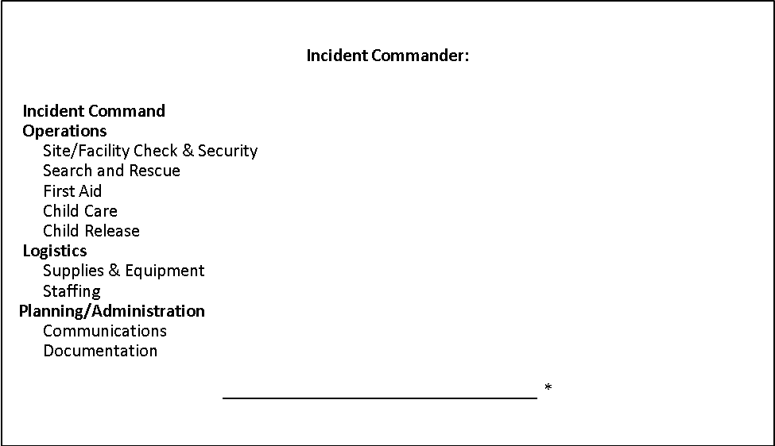

Family or Community Volunteers who’ve agreed to help. (Background checks are complete.)

Organizational Chart – 2-3 People

For 2 people: 1 person is the Incident Commander; 1 person is responsible for Child Care
For 3 people: Add 1 person to Child Care
2-3 Staff

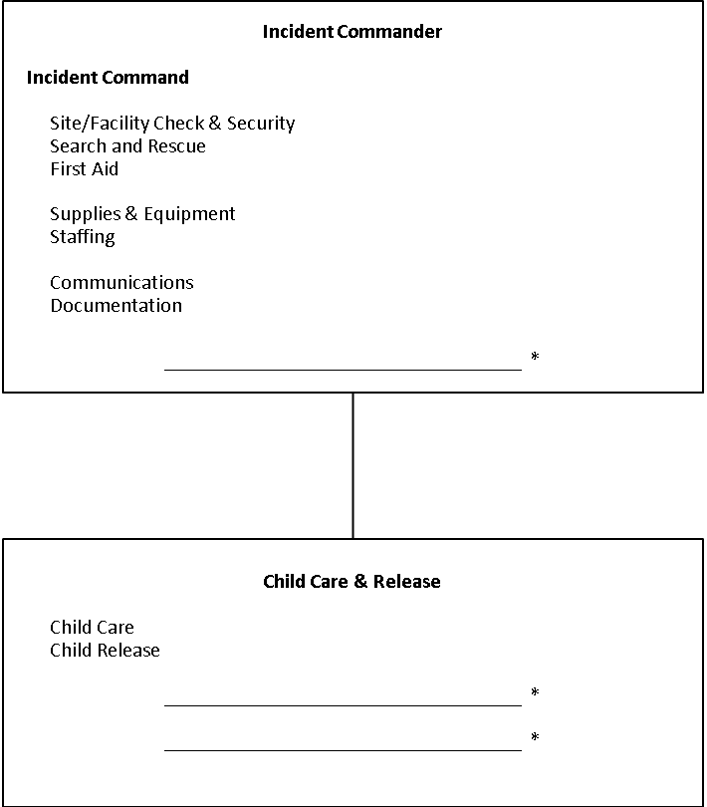

Family or Community Volunteers who’ve agreed to help. (Background checks are complete.)

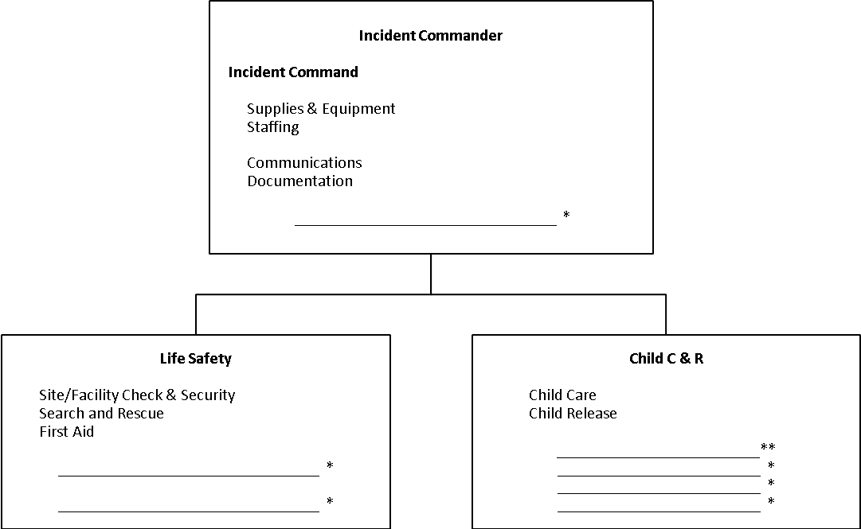
Organizational Chart – 4-7 People

For 4 people: 1 person is the Incident Commander; 1 person provides Life Safety; 2 people are responsible for Child Care
For 5 people: Add 1 person to Child Care
For 6 people: 1 person is the IC; 2 people perform
Life Safety; 3 people are responsible for Child Care
For 7 people: Add 1 person to Child Care
4-7 Staff

8-9 Staff
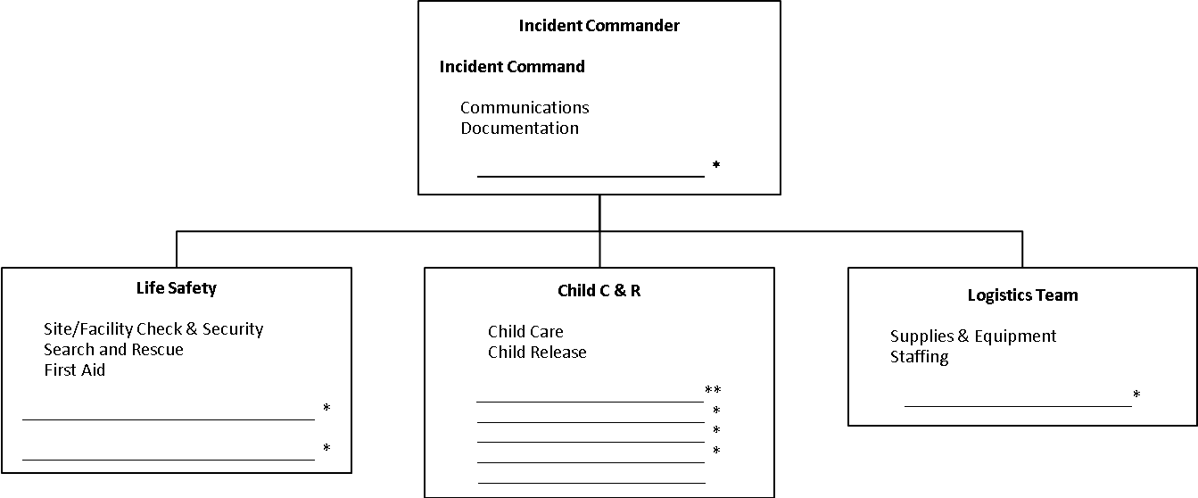
Organizational Chart – 8-9 People

For 8 people: 1 person is the IC; 2 people perform
Life Safety; 1 person takes care of Logistics; 3 people are responsible for Child Care
For 9 people: Add 1 person to Child Care

10- 11 Staff

Organization Chart – 10-11 People

For 10 people: 1 person is the IC; 1 person is the Operations Chief; 1 person takes care of Logistics; 2 people provide Life Safety; 5 people are responsible for Child Care
For 11 people: Add 1 person to Child Care

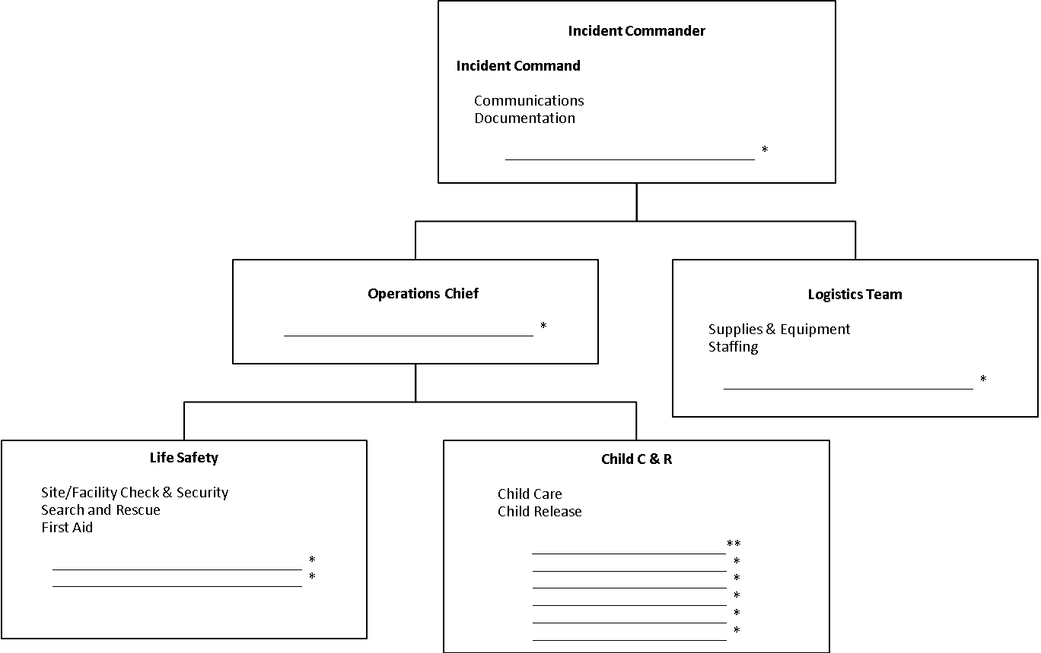

12- 13 Staff

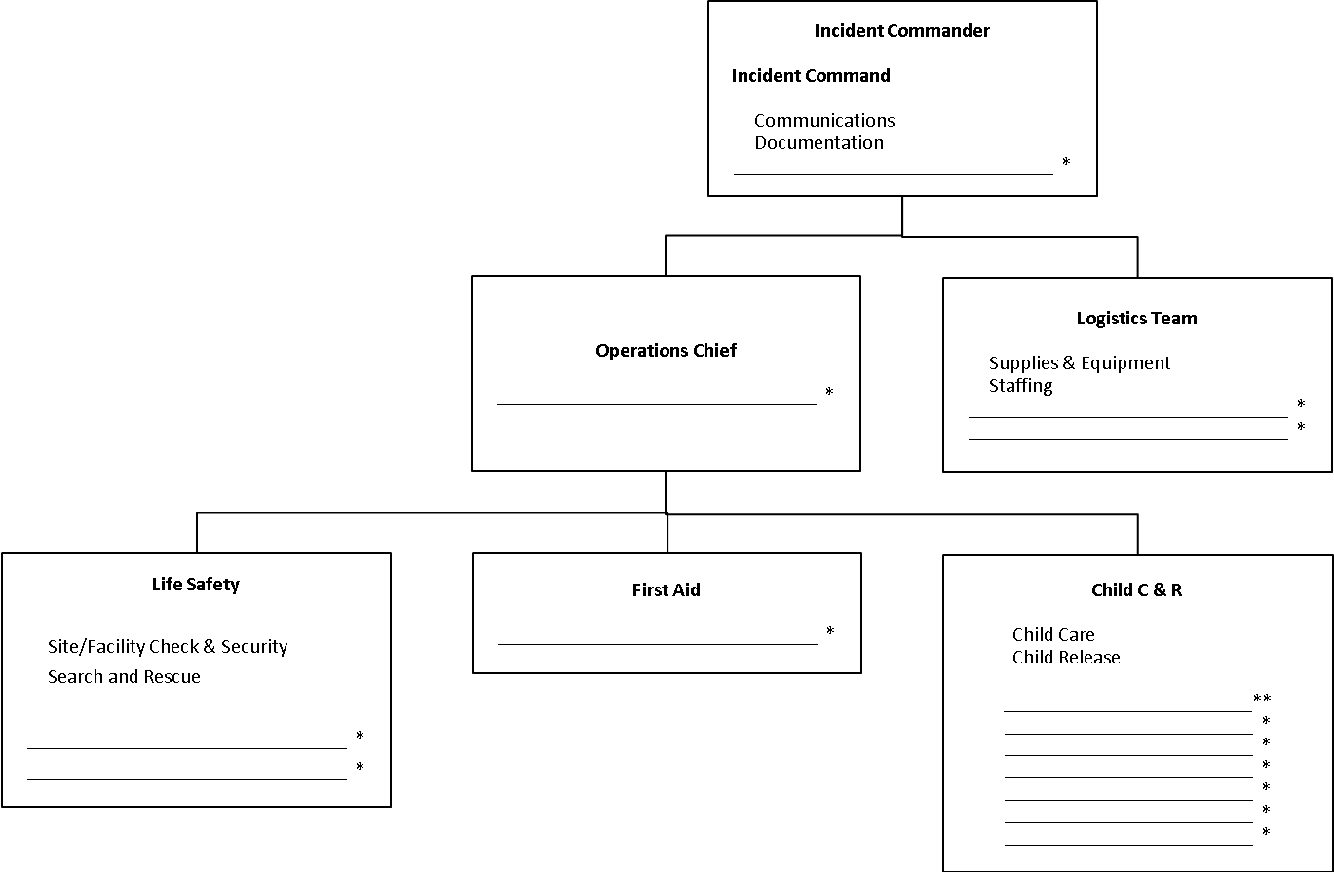
Organizational Chart – 12-13 People

For 12 people: 1 person is the IC; 1 person is the Operations Chief; 1 person takes care of Logistics; 2 people provide Life Safety; 1 person does First Aid; 6 people are responsible for Child Care
For 13 people: Add 1 person to Child Care

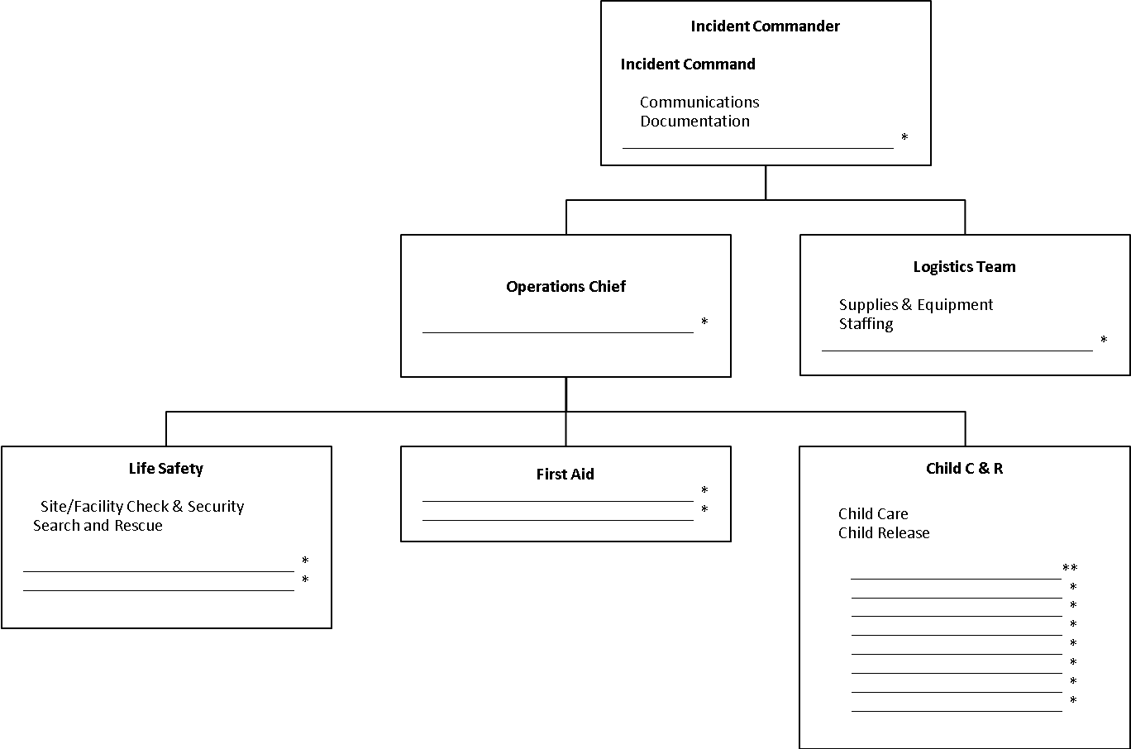
14-15 Staff

Organizational Chart – 14-15 People

For 14 people: 1 person is the IC; 1 person is the Operations Chief; 1 person takes care of Logistics; 2 people provide Life Safety; 2 people do First Aid; 7 people are responsible for Child Care
For 15 people: Add 1 person to Child Care

36 Staff
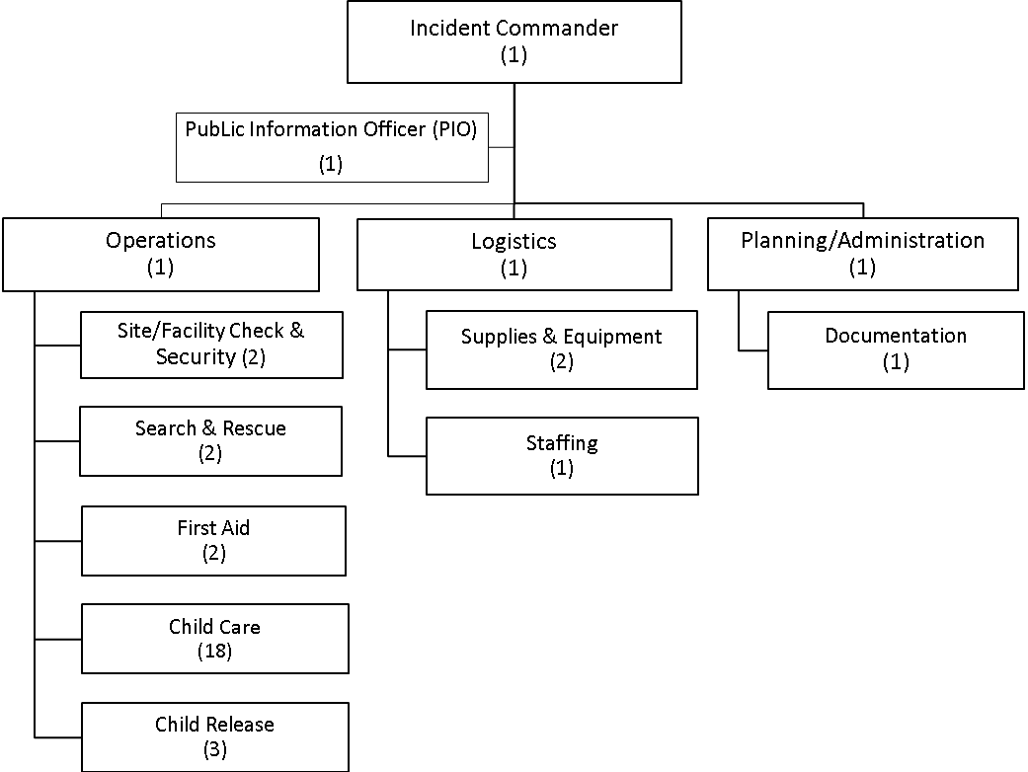

Crisis Support
When a tragedy strikes, teachers and staff are torn between the need to deal with children’s reactions at the same time they are coping with their own reactions. With some advanced planning, this process can be much smoother (and healthier) than when tragedy takes a child care center by surprise.

Crisis: A sudden, generally unanticipated event that profoundly and negatively affects a significant segment of the child care population and often involves serious injury or death. The psychological and emotional impact will be moderate to severe. Outside assistance may be needed.

- Director/Designee will determine whether or not to maintain normal schedules or to set aside the normal schedule for an all out effort to deal with the crisis. Depending on the crisis, it may be necessary to close the center for the day. Center should be reopened as soon as appropriate to provide normalcy back into the lives of children, parents and staff.
- Center Director/Designee will coordinate activities with on scene police or fire if it is that type of emergency.
- Identify high risk children, staff and parents likely to be most affected by the news (e.g. children of the teacher who is deceased/injured or parents whose children are in the same class as the deceased, best friends, etc.).
- Gather and inform closest friends of the victims, provide support and information to them before a general announcement is made. If close friends or classmates are absent, assure that a supportive adult gives the news to them, ensuring that they do not get initial information from the media.
- Give teachers the facts about the tragedy and instructions on how to share the information with the children in their care as well as suggestions for assisting children to cope (see information links with this plan on the website).
- Send a letter home to parents explaining the situation. Include specific factual information and information on how the child care is handling the situation. Include a handout on Typical Children’s Reactions (see information links with this plan on the website).
- Some parents will need to be contacted by phone, particularly if their child’s reaction to the crisis is severe. Talk directly with the person picking up the child about the situation and possible reactions (see links with this plan on the website).
- Determine if additional community resources are needed to be on “stand by” to effectively manage the crisis. It is essential to minimize the number of “strangers” standing around but bring in extra staff to help with meals or other logistics so familiar staff are with the children. Trained Early Childhood Crisis Counselors can act as advisors to the staff.
- Facilitate a staff meeting and, if possible, a parent meeting to provide information related to the crisis (see links with this plan on the website). The following are some suggested activities:
    - Assist with children’s processing of information about the crisis
    - Provide counselors comfortable with working with young children and trauma to work with children/staff individually or in groups in a variety of locations
    - Provide support and counseling for parents
    - Provide childcare while parents attend support activities
    - Provide helpful, factual information to parents
    - Have an individual assist with answering phones, providing information and handling non-media inquiries
    - Maintain a record of offers of assistance and ensure that proper personnel respond
    - Deal with the “empty chair/desk” problem. For example, a counselor would provide support while sitting in the child’s chair. The chair would then be moved to the back of the classroom. Finally the chair would be removed. Make sure children are part of the entire process. Allow children to be part of taking down artwork that was done by the missing person or a picture of them and replacing it with something else. This can be done days or weeks later.
- Assign a familiar staff to act as Family Liaison between the child care center and the family. When appropriate, contact the friends/family of the deceased to get information regarding funeral arrangements and pass on information to child care staff and parents who may wish to attend. If a parent feels it’s appropriate for their own children to attend the funeral/memorial, they must attend with them and provide support to their own child.
- Arrange with appropriate community resources for a Parent Informational Evening and child care/community support activities 48-72 hours after the event.
- Other considerations:
    - Have designated locations for the use of media, family, friends and workers, as needed. Keep media separate from families, children, friends and workers.
    - Have transportation available to assist the family
    - Young members of the victim’s family should be cared for if possible
    - Children and staff should be given permission to feel a range of emotions. Typically, individuals go through a sequence of emotional reactions following a crisis: high anxiety, denial, anger, remorse, grief and reconciliation
    - Provide for grief counseling. Possible contacts:

Ted E. Bear Hollow 402-502-2773

Compassionate Friends 402-571-4011
Grief Care Share Group 800-395-5755.

Crisis Communications
Communication in a crisis will help set the stage for effective response, help to manage parents and the community, and begin the healing process by providing appropriate information in a timely manner.

It should not be assumed that the Director will take on all the Crisis Communication activities. The Director may become the Spokesperson for the center with someone else assigned to the writing and coordination of communication activities.

- Director/Designee will determine whether or not to maintain normal schedules or to set aside the normal schedule for an all out effort to deal with the crisis. Depending on the crisis, it may be necessary to close the center for the day. Center should be reopened as soon as appropriate to provide normalcy back into the lives of children, parents and staff.
- Center Director/Designee will coordinate activities with on scene police or fire if it is that type of emergency.
- If center is affiliated or shares a physical location with another organization, a college for instance, then the other organization should be notified immediately.
- Director/Designee will determine if parent notification becomes an item of priority or can wait for a letter to go home in the evening.
- If center specific - Director/Designee will designate someone to keep the local radio stations informed as to the status of the child care so parents will have accurate information. Use a Spokesperson from your own staff or work with the Public Information Office of the responding agencies or affiliated organization.
- Gather and inform closest friends of the victims, provide support and information to them before a general announcement is made. If close friends or classmates are absent, assure that a supportive adult gives the news to them, ensuring that they do not get initial information from the media.
- Prepare a formal statement for initial announcement, include minimum details and note additional information will be forthcoming. Also prepare statements for telephone and media inquiries. Have someone who does not get overly emotional answer phones and direct them to not guess about information they don’t have; stick to the facts that have been approved for release.
- Give teachers the facts about the tragedy and instructions on how to share the information with the children in their care as well as suggestions for assisting children to cope (see information links with this plan on the website).
- Send a letter home to parents explaining the situation. Include specific factual information and information on how the child care facility is handling the situation. Some parents will need to be contacted by phone, particularly if their child’s reaction to the crisis is severe.
- Plan on updating information frequently.
- If possible, use multiple communications methods… direct contact with parents, written fact sheets, media, social media, meetings and other methods.
- Conduct a short Staff Informational meeting when children have all been released Give them current information, praise them for a difficult job well done and prepare them for the next steps.
- Inform staff and parents about any planned Staff, Parent or Community meetings.
- (Title of individual) will deal with media/reporters promptly and factually. Coordinate messaging with Public Information Officer from fire or police if they are on scene.
- Provide appropriate information as requested by police, hospital, or other agencies.
- Director/Designee will report incident to licensor at earliest convenience.
- Director/Designee will report incident to Child Protective Services if necessary.
- Director or designee will complete a written incident report at the earliest opportunity; incident reports are stored (where).

Parent-Child Reunification

Once a child is left in the care of your program, the people who work in the center are responsible for the child until s/he is picked up by a parent/guardian or emergency contact. The process for tracking children after a disaster is different – and more difficult – than during normal, everyday operations.

There are various reasons why child release differs after a disaster. Children must be released only to family members or emergency contacts that have been pre-designated on the emergency contact list or registration forms. Each release must be documented, with information about with whom and where the child is going. The process also creates privacy, so if a child is injured, his/her family can be given the news away from other waiting families. This is not only more respectful towards the family involved, but it also prevents other families from becoming more upset while waiting for their own children.

The success of your release procedures relies in large part on prior explanation and practice for staff. Everyone will respond better to this disaster procedure if they know about it ahead of time. It is important to explain to families that the reunification process may take longer after a disaster, and why that is.
- Think about a good place for parents/guardians and emergency contacts to check in
- A good place for a release area that is out of sight of the check-in gate
- Copy Child Release forms, and store them with copies of emergency contact forms and other needed supplies in a go-kit, such as:
  - Signs
  - Pens
  - Clipboards
  - Extra paper
  - Tape

All Families should be reminded of the importance of listing emergency contacts and keeping those contacts updated. Encourage families to include at least one emergency contact that is within walking distance of your program, if possible. Remind parents/guardians that people listed as emergency contacts need to know that they are being counted on. They also need to know that everyone’s ID will be checked for their child’s, or children’s, safety. Children will not be released to those not listed as emergency contacts. If people are concerned about not having ID during a disaster, offer to file pictures of emergency contacts, or copies of their ID’s, with the child’s emergency contact information.

It is important to thoroughly document how each child leaves the facility. In the event that a second adult shows up to pick up the child, you are then able to tell them where the child went and who picked them up. Having the adult tell you the destination is also very important so you can relay that to the other parent/guardian as needed. Documentation is extremely important during disasters to that you can review them at a later date if required to do so.

Reunification Stations
There are five very important stations when setting up an alternate location and reunification plan.

- The Check-In Gate staff will be the first to greet the parents/guardians/emergency contacts upon arrival. This is where the Post Disaster Child Release Form begins. The staff and adult fill out sections one and two at this station. A sign advertising the Check-In Gate is encouraged. It should NOT be visible from the Child Care Area to minimize agitation in an already chaotic situation. It is also very important not to circumvent the necessary documentation.

- The Child Care Area is where staff will care for all the children still in their care. Staff will need to make sure that the child’s needs are being met and they are being entertained. This is can be very traumatic for the children and they will need more to do than sit and wait for their parents. The Child Care Area is where section three will be filled out by staff.

- The Release Gate will be one of the last places the adult and children see. This is where you will finish filling out sections four through six on the form. The Release Gate is the place that the child/adult will be reunited to head home.

- The Command Post is where the Commander and support staff will work from. The Commander may be the Director, or it may be the most qualified staff member on hand. The Command Post is not usually accessible to parents, but can be if the Commander feels it’s necessary.

- A Private Area not visible to children and parents is necessary for the Commander, Director or Designee to bring a parent or guardian to tell them if their child or children are missing, injured or deceased. It offers privacy and prevents other parents from becoming more agitated during chaotic circumstances.

Release Procedure
For the safety of staff and children, parents/guardians are restricted to the Check-in and Release Gates. A runner will be assigned to go get the child when the parent/guardian arrives.
- The release procedure begins at the Check-in Gate, where a parent/guardian or emergency contact begins filling out the child release form.
- A runner, if available, will then take the form to the Child Care Area to pick up the child.
  - The form is then signed by the staff assigned to that Child Care Area, releasing the child.
  - The runner will then take that child and form to the Release Gate.
    - Staff at the Release Gate and parent/guardian/emergency contact will complete the form together.
  - The Completed form will be filed at the Release Gate.
- ***If the child is injured/missing/deceased the process stops and the runner will take the form to the Command Post. Someone from the Command Post will contact the family away from everyone else and explain the situation.***

The following template form is encouraged to be used during the Reunification Process. Make many copies and store them with your center’s go-kit of administrative supplies.

Post Disaster Child Release Form
Section 1 – Completed by Parent/Guardian/Emergency Contact at Check in Gate
- To be completed by Parent/Guardian/Emergency Contact and returned to Check-in Gate Staff | Child’s Name:______________________________________  Teacher: _________________________________________  Classroom:________________________________________
Section 2 – Completed by Gate Staff at Check in Gate
- To be filled out by Gate Staff  - Upon completion, given to runner to get child.  - Adult will be escorted to release gate | Parent/Guardian/Emergency Contact name:  Proof of ID : ____________________________________  Confirmed that this person is on the Emergency Contact Sheet: Yes ______ No ______ Staff Initials:
Section 3 – Completed by Child Care Area Staff at Child Care Area
- To be filled out by Child Care Area Staff  - If child is present, send with runner to the Release Gate  - If child is absent, missing, or injured, send form with runner to Command Post | Child’s Status:  Present ________ Absent ________  First Aid ________ Missing________  *Child Care Area Staff to initial next to appropriate status.
Section 4 – Completed by Release Gate Staff at Release Gate
- To be completed by staff at Release Gate  - Upon Completion, give to parent/guardian/emergency contact to fill out section 5 | Name of Parent/Guardian/Emergency Contact picking up child (Must match name at the top of the form)  __________________________________________________  Confirmed that this person is on the Emergency Contact Sheet:  Yes ______ No ______ Staff Initials:
Section 5 – Completed by Parent/Guardian/Emergency Contact at Release Gate
- To be completed by Parent/Guardian/Emergency Contact and returned to Release Gate Staff | Parent/Guardian/Emergency Contact signature:  __________________________________________________  Destination:_______________________________________  Date:____/____/________ Time: ____:____ am/pm
Section 6 – Completed by Release Gate Staff at Release Gate
- To be completed by Release Gate Staff and file at release gate | Signature of Release Gate Staff:  __________________________________________________  Date:____/____/________ Time:____:____ am/pm

Appendices

Appendix A: Sample Parent Letter

Date

Dear Child Care Parents:

Attached please find a copy of our “Disaster Response Handbook” – or - Near the sign-in desk you will find a copy of our “Disaster Response Handbook”. Please take the time to read and become familiar with our procedures. With the implementation of this handbook you can rest assured we will do everything we can to protect and care for your child in the event of a crisis or disaster.

With any disaster or crisis, your cooperation is necessary for the following:
- Encourage and explain to your child why the best place for them is at the child care center.
- Explain that if you are unable to pick them up quickly, the child care staff will care for them until you or your emergency contact comes to get them.
- Please do not immediately telephone the child care. Telephone lines will be needed for emergency personnel. Please call the center’s out-of-area contact for information or to relay messages during a disaster.
- Listen to local television and radio stations for updates (see page 5 for contact information).
- Provide an emergency/comfort kit for your child.
- Include an out-of-state contact number for your family with your kit.
- Provide a 72-hour supply of any medication or medical supplies/equipment that your child may need.

The child care staff will care for your child until you or your designee is able to reach them. Be sure to keep your child’s emergency release card updated. Children will only be released to those specified by you on their card. We will also utilize the phone numbers on the emergency release card should we need to re-locate to our alternate site.

If local telephone lines are unavailable, utilize your out-of-state contact number for information. If possible, we will call that number to give information on your child and to see if you have left any information for us.

Thank you for your attention to this matter. Please feel free to contact the child care if you have any questions regarding our crisis/disaster response handbook. After reading this plan, parents should complete the following page and return it to the center director.

Keeping your children safe,

Center Director
Sample Parent Communication Form

Dear Parent or Family,

During a disaster, communication may become challenging. Often it is easier to contact a long-distance phone number than a local or cell number. Our facility is establishing an out-of-area number to relay information throughout a disaster. Please put this number in a convenient and accessible place so that you are able to get information about your child should local calling become challenging. Our out-of-area contact is:

Name: _______________________________________________________________

Phone #: ____________________________

We encourage you to familiarize yourself with the disaster plans and policies established for our child care facility. If you have not already been given this information, it will be provided for you by:

Date: _______________________________

Please sign and return the following portion

I have received information regarding your child care facility’s out-of-area emergency contact.

I understand that your child care facility has established policies to respond appropriately to a disaster.

Signature: _____________________________________ Date: __________________

Please provide the following information for our emergency records:

Child’s name: __________________________________________________________

Child’s out-of-area contact (100+ miles away):_________________________________

Emergency contact (friend, family or loved-one): _______________________________

Local contact (the “nearest” acquaintance): ___________________________________

Appendix B: Disaster Supplies

Supplies can be costly to purchase all at once. To ensure that you have the appropriate supplies:
  - Review the lists and decide what is a priority for your site
  - Develop a “supply rotation system” that allows you to use perishable supplies in your normal operations before the expiration date
  - Team up with another organization to buy supplies in bulk
  - Request specific donations from families or a disaster supply fee
  - Seek donations from the community.

Supplies need to be accessible in the event of an emergency. It is often best to have a few essential supplies in a backpack or duffel bag near the door. This is called a “Grab and Go” bag (see next section for more information). The bulk of your supplies should be stored in a water-tight container, such as a plastic bin or a garbage can. This should be kept near an outside door or in an outdoor shed.

Grab & Go Bags
A “Grab & Go” bag contains necessary items for an emergency. Also called go-kits, these are items you may need within the first hour or two after a disaster. The bag only contains a small portion of your disaster supplies, but is a key part of your preparedness.

The “Grab & Go” bag is designed to meet immediate needs for a limited time. For example, it does not need to have formula and diapers for all infants. Make sure you have enough supplies in your 3-day disaster supply kit. You should have one bag for each classroom.

Your labeled “Grab & Go” bag should contain:
- Current emergency forms for students and staff
- “Necessary” medications with authorization forms (such as a EpiPens®, asthma inhalers, or any other medications that a specific child may need to keep him/her alive)

- First aid kit
- Flashlight and batteries
- Whistle
- Bottle of water
- Age-appropriate snacks/infant formula
- Paper cups and/or infant bottles
- Tarp or ground cover and emergency blankets (such as space blankets)
- Tissue or toilet paper and/or wipes and diapers as needed
- Plastic bags
- Age-appropriate time-passers (books, crayons, paper, etc)

Make sure you have a system in place for keeping emergency contact information current. Check expiration dates of food, water, batteries, and any medication, and replenish those items regularly. Keep first aid supplies fully stocked.

A “Grab & Go” bag should be easy to grab/transport. Make sure you can easily carry it. A backpack is ideal. Your bags should go everywhere your class goes. If your class is inside their classroom, the best place for the bag is on a hook by the door that you would usually use to exit (and the exit that you are most likely to evacuate through). When you leave the classroom, always take it along. Your “Grab & Go” bag should be with you on: the playground, field trips, fire drills, or any other planned or unplanned classroom departure. The “Grab & Go” bag should be out of the reach of children at all times.

Comfort Kits
You may want to have small comfort kits for each child stored with your main disaster supplies. Many disaster supply companies sell pre-made kits. Alternately you can give each parent a gallon size Ziploc bag and the following list:
- Wool socks
- Hat
- Photo/letter from home
- Small toy or book
- Mylar (space) blanket

Car Kits
You never know when a disaster may strike. Have emergency supplies in your car along with a first aid kit. Consider including the following items:
- Flashlight
- Batteries
- Non-perishable food
- Bottled water
- Blanket
- Comfortable walking shoes
- Flares
- Booster cables
- Small fire extinguisher

Food
Choose a variety of non-perishable foods that require little or no preparation. Rotate food items every 6 months. Try to select items that the children like to eat and ones low in sugar and salt. A sample menu and shopping list is found on the next page. Some ideas include:
- Commercially canned or processed foods, ready-to-eat meats, fish, pastas, fruit, and vegetables
- Canned evaporated or powdered milk
- Crackers, granola bars, energy bars, trail mixes, and cereals
- Freeze-dried foods, salmon/beef jerky, dried fruit, such as for camping
- Peanut or nut butter (provided no one is allergic)
- A personal energy booster for staff such as a candy bar, instant coffee, hard candies, or tea bags
- Infant formula and baby food for babies or other special foods for people with specific dietary needs
3 Days Emergency Menu for Child Care Facilities (serves 120)

DAY ONE
Meal | Food | Portion Size
Breakfast | Cheerios  Mandarin Oranges  Milk (dry milk powder + water) | ½ cup  ½ cup
Lunch | Tuna  Saltine crackers  Green Beans  Peaches | 1 ½ oz  4  ¼ cup  ¼ cup
PM Snack | Granola bar  Pineapple juice | 1  ½ cup
Dinner | Canned Spaghetti with meatballs  Green beans  Pears | ½ cup  ¼ cup  ¼ cup
DAY TWO
Meal | Food | Portion Size
Breakfast | Cornflakes  Applesauce  Milk (dry milk powder) | ½ cup  ½ cup
Lunch | Canned Chili  Corn  Triscuit crackers  Apricots | ½ cup  ¼ cup  4  ¼ cup
PM Snack | Graham crackers  Apple juice Dried prunes. | 2 pieces  ½ cup  2 T
Dinner | Canned beef stew  Crackers  Corn  Peaches | ½ cup  2  ¼ cup  ¼ cup
DAY THREE
Meal | Food | Portion Size
Breakfast | Cheerios  Orange Juice  Milk (dry milk powder) | ½ cup  ½ cup
Lunch | Baked beans  Saltines  Corn  Pineapple chunks | ½ cup  4  ¼ cup  ¼ cup
PM Snack | Granola bar  Apple juice | 1  ½ cup
Dinner | Canned ravioli  Green beans  Fruit cocktail | ½ cup  ¼ cup  ¼ cup

Bottled water: 1 gallon per person per day

3 Day Menu Grocery List for Child Care Facilities (serves 120)

Protein Group
CN Labeled Chili *  Canned Beef Stew *  Canned Ravioli (CN Label) *  Canned Spaghetti/Meatballs *  Water packed Tuna  Baked Beans | 15 oz. can = 4 servings  15 oz. can = 4 servings  15 oz. can = 4 servings  15 oz. can = 4 servings  12 oz. can = 6 servings  28 oz. can = 6 servings | 5--#10 cans  5--#10 cans  5--#10 cans  5--#10 cans  32—6 12/ oz. cans  5--#10 cans

GRAIN/BREAD GROUP
Cheerios  Corn Flakes  Saltine crackers  Graham crackers  Triscuit crackers  Granola bars | 20 oz. box = 20 servings  24 oz. box = 20 servings  16 oz. box = 38 servings  14.4 oz. box = 13 servings  13 oz. box = 22 servings  12 per box | 20—20 oz. boxes  10—24 oz. boxes  10—16 oz. boxes  4—16 oz. boxes  6—13 oz. boxes  20 boxes

FRUIT/VEGETABLE GROUP
Canned Orange Juice  Canned Pineapple Juice  Canned Apple Juice  Canned Green Beans  Canned Peaches  Canned Apricots  Canned Applesauce  Canned Corn  Canned Pineapple chunks  Canned Mandarin oranges  Canned Pears  Canned Fruit cocktail  Dried Prunes | 46 oz. can = 10 servings  46 oz. can = 10 servings  46 oz. can = 10 servings  14.5 oz. can = 6 servings  29 oz. can = 7 servings  29 oz. can = 7 servings  48 oz. jar = 9 servings  15 oz. can = 7 servings  20 oz. can = 5 servings  11 oz. can = 5 servings  29 oz. can = 7 servings  30 oz. can = 8 servings  24 oz. bag = 18 servings | 12- 46 oz. cans  12—46 oz. cans  24—46 oz. cans  3--#10 cans  8--#10 cans  4--#10 cans  3--#10 cans  3--#10 cans  4--#10 cans  4--#10 cans  4--#10 cans  4--#10 cans  16# prunes

MILK GROUP
Nonfat Dry Milk Powder ** |  | 5 Boxes
* CN Label = Child Nutrition Program approved product
** Mix with water for fluid milk to use on cereal or for drinking.

EXPIRATION DATES:
Try to purchase foods that will last for at least 6 months or a year. Restock food supplies on a planned schedule (every 6 months or annually) according to expiration dates.

Water
Allow a minimum of 1 gallon per person per day. Include both staff and children in your count. Store your water in a cool place. Put some in your freezer if you have space, where it can help to keep food cold in a power outage.

You can purchase water or collect it yourself. If you choose to collect your own water, make sure it comes from a safe source and is stored in bottles previously used for non-dairy beverages only. Wash, rinse, and sanitize all bottles. Do not use old milk jugs. Replace water you bottle yourself every 6 months. If you purchase water already bottled, replace it before the use-by-date.

In an emergency, if water must be treated, boiling is the best way to kill bacteria and parasites. If bleach is used to treat the water, add 10 drops per gallon for clear water and 20 drops per gallon for cloudy water. Use only unscented, 5% or 6% liquid chlorine bleach. Allow the bleach treated water to sit for 30 minutes before using it. Be aware that bleach may not destroy all the disease causing organisms. Have an eye dropper for measuring bleach in your kit if you decide to use bleach to disinfect water.

Your hot water heater is a great source of water in an emergency. Make sure you know how to shut off the intake and outlet valves—this is to trap the water inside the tank and prevent contaminants from getting inside. It is also a good idea to flush your water heater annually. Check with your manufacturer’s recommendation. Make sure it is strapped to wall studs to prevent tipping over. Don’t rely on the water heater as your only source of water.


SAFETY & FIRST AID (for 50 persons)

Water  - 3 gallons of water per adult  (1 gallon/adult x 3 days)  - 1.5 gallons of water per child  (1/2 gallon/child x 3 days)  - any tools needed to open water containers  - cups and other items needed to dispense water  Stored: _____________________________  Food  Emergency Food:  - Is easy to serve  - Does not require cooling or heating  - Has a long shelf life  - Is stored protected from heat, cold, and pests  - Our emergency food is part of our regular menu rotation. Food for 3 extra days is always on site. (Familiar food can be a comfort during a disaster.) It is rotated _____________________ (how often) by ____________________ (whom).  - We have a separate supply  of emergency food. Expiration dates are checked  _____________________ (how often) by ____________________ (whom).  We include food for those with food allergies or on special diets. We include age-appropriate food, such as formula and pureed food for infants (when enrolled).  Supplies kept with food include:  - Plastic dishes and utensils  - Manual can opener  - Bottles for infants  Stored: ________________________________ | Shelter  - (2) 12’ X 16’ tarps  - (3) 10’ poles  - (100 ft) ¼ in. nylon rope  - flashlight w/ (2) extra sets of  batteries per staff person  - blanket (fleece, wool, &/or “space”) per person  - (5) extra blankets  - (30) plastic sanitation bags  - privacy shelter  - (30) rolls toilet paper  - (50) sanitary napkins  - (30) plastic garbage bags  - (30) rolls paper towels  - (750) soap towelettes packets or baby wipes  - (15) bars of soap  - (5) 5 gal plastic buckets for  sanitation/emergency toilets  - Pine sol or similar product for toilet odor control  - (30) 12-hour light sticks  - battery-operated lantern w/extra batteries  - extra clothing  - books, games, or small toys  Stored: ________________________________  Special Equipment/Other  - Medical supplies for children with special health care needs: ________________________________________________________________________________________________________________________  - Pet supplies (if applicable) ____________________________________________________________  Stored: ________________________________
LIFE SAFETY & FIRST AID (for 50 persons)
Life Safety  - (2) laminated maps of site  - (6) hardhats  - (1) am/fm battery powered radio  - (4) walkie talkies  - (4) whistles  - (1) orange/safety vest per staff member  - (2) shovels  - tools for simple search & rescue*:  - (1) bolt cutter  - (1) pry bar  - (1) crowbar  - (1) pliers  - (1) hammer  - (1) set of screwdrivers  - (1) wrench  - (1) utility knife  - (3) rolls barrier tape  - (3) rolls duct tape  - Other: _____________________  - Other: _____________________  - Other: _____________________  * For search and rescue training, contact your local emergency management agency.  Stored: ______________________________ | First Aid  - masking tape  - permanent marking pens  - first aid reference book  - assorted adhesive bandages  - (100) 4 in. by 4 in. compresses  - (15) 8 in. by 10 in compresses  - (50) roll gauze bandages  - (5) triangular bandages  - (2) sm, med, and large  cardboard splints  - (20) steri-strips or butterfly  bandages  - (5) boxes of water in sealed  containers for flushing wounds, etc.  - (1) small bottle bleach  - (1) backboard  - (1) scissor  - (3) tweezers  - (100) non-porous medical gloves  - (5) oval eye patches  - (7) rolls 1” cloth tape  - (5) rolls 2” cloth tape  - (25) dust masks  - thermometer  - 3-day supply of critical medications, with authorization forms  - instant hand sanitizer  - eye wash  - pocket CPR mask  - alcohol wipes  - safety pins  - Other: _______________________  Stored: ______________________________

ADMINISTRATIVE (for 50 persons)
Administrative Supplies
- master keys to facility and supply container(s)
- copy of disaster plan
- office supplies
- pens
- paper
- tape (Duct and regular)
- stapler & staples
- clipboards
- (2) sets staff and student rosters
- Current Emergency Contact forms
- “Check-In” signs for child release
- Post Disaster Child Release forms
- copies of all necessary forms, such as:
- incident report forms
- first aid log (or notebook)
- staff time log (or notebook)
- expenditure log (or notebook)
- communications log (or notebook)
- Copies of important papers such as insurance documents, utility account numbers, etc.
- Money (change or small bills)

Stored: ______________________________________________________________________
*A file box is an example of a container that would hold everything and then be used to file paperwork later.

- Our supply inventory is complete; we have obtained all needed supplies (on-site supplies are indicated by a check in the boxes above). We have a plan for rotating perishable items.
- We are continuing to gather supplies. The supplies we have on site are indicated above. We have a plan for rotating perishable items. Our plan for obtaining additional supplies is as follows:

Supplies needed | Plan to obtain | Date to be completed | Person Responsible

Appendix C: Hazard Mitigation
Hazard mitigation is a term that means to minimize or eliminate the impacts of hazards before they happen. Hazard mitigation is not a onetime thing. It is imperative to continually check areas and objects throughout your facility on an on-going basis. It is recommended that you do a walk-through of your facility at least once a month, or more, checking for any hazards that can be corrected.

Hazard Mitigation Priorities:
- Would/could it break and fall and hurt someone?
- Would/could it break and fall and block a primary exit from the room?
- Would/could it break and fall and keep your program from opening the next day (or soon thereafter)?

Washington State Emergency Management Division has created some great videos for how best to prepare for a disaster and lessen hazards in your building. To view the videos:
- Open your internet browser to any search engine of your choice.
- Type in: Washington State Emergency Management
- Open the link for the Emergency Management Division (usually the first link)
- Hovering over the “Preparedness” Link, you will see an option for “preparedness videos”. Click on that link.
- http://www.emd.wa.gov/preparedness/prep_personal_prep_video_index.shtml
The Hazard Mitigation Form on the following page tracks the work done to reduce any hazards in the child care. Copy and complete one form for each room, including classrooms, offices, hallways, storage rooms, and the kitchen.

Earthquake Hazard Mitigation
You can never tell when there will be an earthquake, but you can take steps to reduce or avoid damage, injuries, or loss of life for the children in your care, your staff, and yourself. Preparing for an earthquake includes things you already do to protect the children’s safety and health, such as having a fire extinguisher handy and maintaining your certifications for first aid and CPR. With additional planning and preparation, the children in your care will have a better chance at surviving an earthquake unharmed.

In an earthquake, most injuries and deaths are caused by loose objects in and on buildings. During the shaking, cabinets and bookcases topple, objects fall out of cabinets, and hanging or large plants fall. Door frames and window jams may be bent when walls move. Doors may slam or jam shut, and window glass can shatter, sending broken glass into the room. Light fixtures, sprinkler heads, and other ceiling components may pop out and fall. Objects mounted on the walls (such as clocks, maps, and art work) may shake loose and fly across the room. The electricity may go out, and the sprinkler systems or fire alarms may turn on.

For more information on Hazard Mitigation and how to secure objects in the room, review “Earthquake Preparedness: What Every Child Care Provider Needs to Know,” FEMA document 240.

Hazard Mitigation Form

Name of Room or Area: ______________________________________________

Safety Action Taken | Date and Comments
Tall or heavy furniture is secured to wall studs

Heavy objects are placed low or properly secured

Shelves have adequate lips or strapping, or are lined with sticky material (such as “Grip It”) to prevent items from flying off in an earthquake
Overhead cupboards have safety latches

Chemicals and poisons are stored safely (including: out of reach of children, in closed cabinets, no bleach and ammonia together)
Windows are of safety glass or are adapted to prevent shattering and injury

Evacuation/exit routes are free from hazards such as equipment, furniture, and other large objects
All exits are unlocked or can be unlocked or locked from the inside without a key

Ongoing room review:
Date & Initials:

Action Taken:

Date & Initials:

Action Taken:

Appendix D: Disaster Drill Records

This appendix includes sample disaster drill records. Choose the ones that work the best for your center. Included on the pages that follow are:

- Child Care/Early Learning Lockdown Drill Record
- Child Care/Early Learning Fire Evacuation Drill Record
- Child Care/Early Learning Earthquake Drill Record

---- This page left intentionally blank ----

Child Care/Early Learning Lockdown Drill Record (recommended: 2 per year)

Date of Drill _______________ Date of Drill _______________
Time of Drill _______________ Time of Drill _______________
Name of Program ____________________________ Name of Program ____________________________

Brief Description of Drill Brief Description of Drill

Rooms Participating in Drill Rooms Participating in Drill

Objectives | Evaluation | Changes to be Made | When Changes are Made
Objectives | Evaluation | Changes to be Made | When Changes are Made

Name of Person Organizing Drill __________________ Name of Person Organizing Drill ___________________

---- This page left intentionally blank ----
Child Care/ Early Learning Fire Evacuation Drill Record (required Monthly drills)
 | January | February | March | April | May | June | July | August | September | October | November | December
Date:
# of students:
# of staff:
Time started and ended:
Comments:
Fill out by: (staff)

---- This page left intentionally blank ----
Child Care/Early Learning Earthquake Drill Record
(Recommended: 4 per year)

Date of Drill __________ Date of Drill _______________
Time of Drill __________ Time of Drill _______________
Name of Program _________________________ Name of Program ____________________
Brief Description of Drill Brief Description of Drill

Rooms Participating in Drill Rooms Participating in Drill

Objectives | Evaluation | Changes to be made | When changes are made
Objectives | Evaluation | Changes to be made | When changes are made
Name of Person Organizing Drill___________ Name of Person Organizing Drill___________

Date of Drill __________ Date of Drill _______________
Time of Drill __________ Time of Drill _______________
Name of Program _________________________ Name of Program ____________________
Brief Description of Drill Brief Description of Drill

Rooms Participating in Drill Rooms Participating in Drill

Objectives | Evaluation | Changes to be made | When changes are made
Objectives | Evaluation | Changes to be made | When changes are made
Name of Person Organizing Drill___________ Name of Person Organizing Drill___________

---- This page left intentionally blank ----

Appendix E: Sample Situation Forms

Attach a copy of your child care's own incident report form here or describe how you keep record of significant incidents that occur. Our child care's incident reports are kept for (how long).

Included in this section are two sample report forms: a "Child Care Situation Report" form and a "Child Care Situation/Conversation Log". Fill out the form completely and leave no blank spaces. If the information is unknown, state that in the blank. Also included is a log to track disaster drills.

Notes about the Child Care Situation Report:
This form should be used to periodically update responding agencies or other groups about the status and needs of your child care in the event of a serious, widespread disaster.

In the message section, include the following information:
Kind of immediate assistance required
If you can hold out without assistance and for how long
Overall condition of the facility, children, and adults
Names of outside agencies at the site and their actions

Notes about the Child Care Situation/Conversation Log:
This form should be used to keep a running log of the activities taking place during any disaster or crisis response. It will become very important when multiple individuals are responding to the situation.

A permanent log may be typed or rewritten at a later time for clarity and better understanding. If you do this, be sure to keep all original notes and records; THEY ARE LEGAL DOCUMENTS.

The following is a sample of how this log can be used and what information to include:

Time | Situation | Response | Initials
1:30 pm | Earthquake | Center was evacuated. | CD
1:45 pm | Susy's mom came to center upset and upset Susy's classmates. | Escorted Susy's mom away from children to compose herself and then let her take Susy home. | CD
1:55 pm | Water running out of bathroom. | Sent Becky to shut off the water main. | CD

Appendix F: Child Care Situation Report Form

To: _______________________________ From: ____________________________

Date: _____________ Time: __________ Location: _________________________

Person in Charge at Site: __________________________________________________
This message was sent via:  2-way Radio  Radio  Telephone
❑ Cellular Phone  Messenger

Description of the Incident/Situation:

Employee/Child Status:
 | # Absent | #  Injured | #  Sent to  Hospital | #  Dead | # Missing | # Unaccounted  for | # Released  to Parents | #  Being  Supervised
Staff
Children
Others

Structural Damage (Areas checked for damage/problems and location(s) of problems):
Checked (X) | Problem Area | Location of problems
 | Gas
 | Water
 | Fire
 | Electrical
 | Communications
 | Heating/Cooling System
 | Main Building
 | Other:
Message:

Post- Disaster Child Care Situation/Conversation Log

Date: _____________________ Incident/Situation: _____________________________

Time | Situation | Response | Initials

Appendix G: Helping Children Cope with Disaster

Disasters can be very frightening and traumatic, especially for young children. There are several things that you can do to help the children in your care cope with their feelings.

Don’t assume children won’t understand what is happening.

- Reassure the children that they will not be left alone and that you are there to protect them.
- Be aware of changes in a child's behavior but also know that some children may not outwardly show their distress.
- Keep to routines such as meals, activities, and naps, as much as possible
- Try to keep familiar adults with the children rather than adding volunteers or substitutes for direct child contact.
- Avoid allowing young children to watch or listen to news coverage of the disaster.
- If child regresses to earlier physical or emotional behavior… wetting, clinging, crying…treat it calmly and efficiently.
- Give simple but truthful answers to children's questions and make sure children understand your answers. Don't give more information than the children can use and understand.
- Give children opportunities to express their feelings through activities such as play-acting, using dolls, storytelling, painting, or drawing. Playacting revenge or aggressive behaviors may be common. Redirect only if it is hurting the child or someone else.
- Be especially supportive of the children's feelings and need to be close. Give lots of hugs, smiles, and kind words.
- Reassure children that they are not responsible for the disaster. Listening to children's stories about disasters and feelings may help and they may need to tell the story again and again.
- If possible, take a moment away from the children and make sure you address your own fears and anxieties by talking with other adults. Be particularly careful to not have children over hear your conversation.
- Seek professional assistance when needed. The Mental Health Checklist included with this plan on the website may help you in determining the need for additional assistance. Your own knowledge of the child and your instincts about the child's needs will also help you make a decision. When in doubt, call for professional help. (List here names and phone numbers of professionals you may call for help such as child psychologists or other mental health professionals).

- In the event of a disaster or crisis, grief counseling may be provided through the P Provide for grief counseling. Possible contacts:

Ted E. Bear Hollow 402-502-2773

Compassionate Friends 402-571-4011
Grief Care Share Group 800-395-5755

Other Resources for Helping Children Cope

National Institute of Mental Health (NIMH)
Information Resources and Inquiries Branch
6001 Executive Blvd, Rm. 8184, MSC 9663
Bethesda, MD 20892-9663
PTSD/Anxiety Disorders Publications:
1-88-88-ANXIETY
Public Inquiries: 301-443-4513
TTY: 301-443-8431
E-mail: nimhinfo@nih.gov
Web site: http://www.nimh.nih.gov

U.S. Department of Education
400 Maryland Avenue, SW
Washington, DC 20202
Phone: 1-800-USA-LEARN
TTY: 1-800-437-0833
E-mail: customerservice@inet.ed.gov
Web site: http://www.ed.gov

Federal Emergency Management Agency
(Information for children and adolescents)
P.O. Box 2012
Jessup, MD 20794-2012
Publications: 1-800-480-2520
Web site: http://www.fema.gov/kids

American Academy of Child & Adolescent Psychiatry
3615 Wisconsin Ave., N.W.,
Washington, D.C. 20016-3007
Phone: 202-966-7300
Web site: http://www.aacap.org/

Substance Abuse and Mental Health
Services Administration's (SAMHSA) National Mental Health Information
P.O. Box 42557
Washington, DC 20015
Phone: 1-800-789-2647
TTY: 866-889-2647
Email: info@mentalhealth.org
Web site: http://www.mentalhealth.samhsa.gov/

American Academy of Pediatrics
141 Northwest Point Boulevard
Elk Grove Village, IL 60007-1098
Phone: 847-434-4000
Web site: http://www.aap.org
American Red Cross
National Headquarters
431 18th Street NW
Washington DC 20006
Phone: 202-639-3520
Web site: http://www.redcross.org

Disaster Training International: Helping Adults Help Children
9400 Ravenna Ave NE # 3
Seattle, WA 98115
206-420-8217
www.disastertraining.info

***The following copyrighted resource materials are included as separate links on the website or along with the templates and video on the CD:
  - 20 Ways to Be…
  - Assessing a Student Need for Intervention
  - Crisis Resource Material
  - Parent Handout: Helping Children Cope
  - Parent Informational Evening Guidelines
  - Sample Parent Letter
  - Symptoms and First Aid: Pre School and Kindergarten
  - The Three Tasks of Grief for Children
  - Words to Use

---- This page left intentionally blank ---

